Properties of Minerals

What is a mineral?

* A mineral is a naturally occurring, inorganic solid that has a crystal structure and a definite chemical composition

5 characteristics that all Minerals Share

1. Naturally occurring
2. Inorganic
3. Solid
4. Crystal structure
5. Definite chemical composition

Naturally Occurring

* Naturally Occurring means that the substance must occur in nature, it cannot be created or manufactured by people.

Inorganic

* Inorganic means that a mineral cannot come from something that was once living.

Solid

* A Solid has a definite volume and shape; its particles are tightly packed together and can not move easily.

Crystal Structure

* Crystal structure means the particles that make a mineral line up in a pattern that repeats over and over again, this pattern creates a crystal

Definite Chemical Composition

* Definite chemical composition means that a mineral always contains certain elements in definite, or exact, proportions

Identifying Minerals

* Each mineral has its own specific properties that can be used to identify it, this is due to the fact that each mineral has its own unique make-up.
* Hardness- Mohs Hardness Scale
* Color
* Streak
* Luster
* Density
* Crystal Systems
* Cleavage and Fracture

Hardness- Mohs’ Hardness Scale

* Hardness (how hard a mineral is) is one of the best properties that can be used to help identify a mineral
* Mohs Hardness Scale ranks 10 minerals from softest to hardest, Talc is softest and Diamond is hardest

Color

* The color of a mineral is a physical property that is easy to observe.
* Color can only be used for a few minerals that have their own specific color

Streak

* Streak tells the color of a mineral’s powder. To find the streak of a mineral you rub the mineral against an unglazed tile called a streak plate.

Luster

* Luster describes how a mineral reflects light from its surface. Such as:
* The most common minerals we will discuss will either be metallic (shiny) or non-metallic (dull)

Density

* Density is the mass in a given space, or mass per unit volume. No matter how large or small the sample of a mineral is, its density will remain the same.
* Density= Mass/Volume D=M/V

Cleavage

* Cleavage is a property that describes a mineral that splits evenly along flat surfaces
* Cleavage is due to how atoms are arranged in the crystals of a mineral

Fracture

* Fracture describes how a mineral looks if it breaks in an irregular way and does not split apart evenly
* 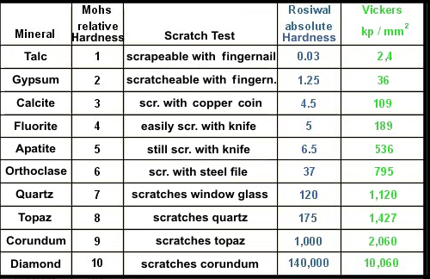Think of bones, bones fracture